MED D - Claim Adjustment and Refund Requests

Claims Adjustment Request – Incorrect Benefits Plan
Claims Adjustment Request – Copay Discrepancy
Claims Adjustment Request – Claim Adjustment Reimbursements
Claims Adjustment Request – Deductible/TrOOP Adjustment
Claims Adjustment Request – Retro LIS
Claims Adjustment Request – Coordination of Benefits Error (Primary/Supplemental)
Claims Adjustment Request – Recoupment - Retroactive LIS/TrOOp Adjustments
Recoupment Letters and Invoices
SilverScript – RMT – Plan Transfer (TrOOP) Adjustment – TrOOP Transfer Dispute
Recoupment FAQs
Recoupment Letter Examples
Senior Team/Offline Team - Submitting Reconciliation Management Team (RMT) SalesForce Case
Log Activity
Resolution Time
Related Documents

Description: This document outlines the research steps to be followed when the CCR is faced with an issue regarding a claim adjustment request, refund check or invoice due to the claims reprocessing effort or when submitting an adjustment (when applicable).

Claims Adjustment Request – Incorrect Benefits Plan
Follow the steps below when a beneficiary has been assigned to the wrong group and has been moved to the correct group.
- This is also known as a plan-to-plan change which has been set up in the wrong group.

Step | Action
1 | Locate the claim(s) or Rx#(s) in question and verify the correct benefits were applied.  Note: Check Member ID, Carrier, Account and Group used for the claim.  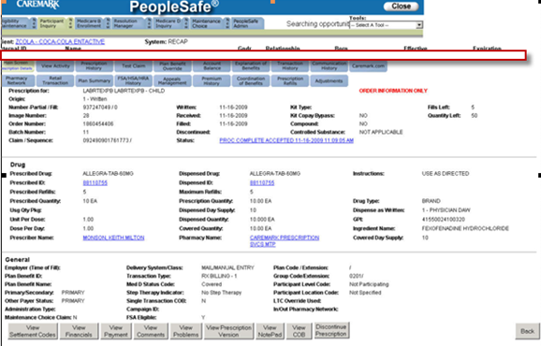
2 | Determine if the beneficiary has been updated into the right plan (also known as a plan-to-plan change) by checking under the Med D Inquiry tab – Enrollment Activity screen.  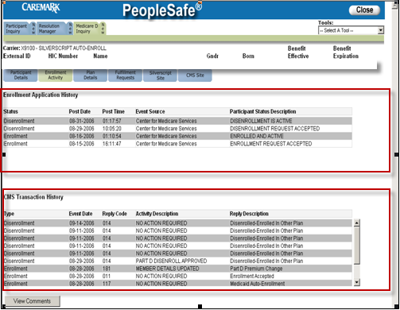
2 | If the beneficiary’s plan… | Then…
2 | Has been recently updated | Proceed to Step 3.
2 | Needs to be updated | Check the CIF for the plan design details to confirm if plan matches what is reflected in PS.
2 | Needs to be updated | If… |  | Then…
2 | Needs to be updated | PS matches CIF |  | Proceed to Step 3.
2 | Needs to be updated | PS does not match CIF |  | Send the following RM Tasks:  Task Category: Billing / Payment  Task Type: Reverse and Reprocess Claim  Queue: Billing / Payment - Participant Services  Reminder: The NOTES section should state: “Please create an adjustment in EAS to move the claims to the new plan  Task Category: Customer Care Internal Process  Task Type: Participant Callback Request  Queue: CC Internal Research/Nashville  Ask if there are any additional benefit questions and proceed to Step 5.
3 | Ask if there are any additional benefit questions.
3 | If…. |  | Then…
3 | Yes |  | Address any benefit issues.
3 | No |  | Proceed to the next step.
4 | Transfer to the Senior Team. Refer to MED D - When to Transfer Calls to the Senior Team and Basic Call Handling.
5 | Document and close the call according to current policies and procedures.

Top of the Document

Claims Adjustment Request – Copay Discrepancy

When a beneficiary is disputing the amount they paid for their copay, follow the steps listed below:
Step | Action
1 | Locate the claim(s) or Rx#(s) in question.
2 | Populate a test claim from an existing claim to validate the copay charged.  Note: DO NOT change the date.  Refer to MED D - Test Claims.
3 | Verify the beneficiary’s benefit stage status.  Refer to MED D Determining TrOOP Status.
4 | Click the Med D Inquiry tab and in View Comments or View Activity tabs check for any of the following:  - Change of plans  - Change of LIS Level  - Retro effective date  - It is important to first determine that a Coverage Determination does NOT apply.  - If it is determined a Coverage Determination IS needed, refer to MED D - Coverage Determinations and Redeterminations (Appeals).  - If a Coverage Determination was recently applied, the beneficiary will need to submit a paper claim. Refer to MED D - Researching and Submitting Paper Claims.
4 | If the beneficiary’s plan is… | Then…
4 | Incorrect | Refer to Claims Adjustment Request – Incorrect Benefits Plan section in this document.
4 | Correct | Proceed to next step.
5 | Ask if there are any additional benefit questions.
5 | If…. | Then…
5 | Yes | Address any benefit issues.
5 | No | Proceed to the next step.
6 | Transfer to the Senior Team. Refer to MED D - When to Transfer Calls to the Senior Team and Basic Call Handling.
7 | Document and close the call according to current policies and procedures.

Top of the Document

Claims Adjustment Request – Claim Adjustment Reimbursements
Follow the steps listed below when a beneficiary is upset or requests additional information about a claim adjustment check(s) and what claims were adjusted. (Example: Retroactive Coverage Determination)

Refer to MED D - Senior Team - Submitting Reconciliation Management Team (RMT) Email.

Step | Action
1 | Locate the claim(s) or Rx#(s) and check reimbursement in question.
2 | Validate the copay charged by performing a test claim.  Refer to MED D - Test Claims.
3 | Determine the beneficiary’s TrOOP status on the date of fill.  Refer to MED D Determining TrOOP Status.
4 | Click the Med D Inquiry tab and in View Comments or View Activity tabs check for any of the following:  - Change of plans  - Change of LIS Level  - Retro effective date
4 | If the beneficiary’s plan is… | Then…
4 | Incorrect | Refer to the Claims Adjustment Request – Incorrect Benefits Plan section in this document.
4 | Correct | Proceed to next step.
5 | Ask if there are any additional benefit questions.
5 | If… | Then…
5 | Yes | Address any benefit issues.
5 | No | Proceed to the next step.
6 | Transfer to the Senior Team. Refer to MED D - When to Transfer Calls to the Senior Team and Basic Call Handling.
7 | Document and close the call according to current policies and procedures.

Top of the Document

Claims Adjustment Request – Deductible/TrOOP Adjustment
This Task will be utilized when a CCR has questions regarding an adjustment to the beneficiary’s TrOOP, as identified in some processed claims or on the monthly EOB statement.

Be sure the adjustment to the Deductible or the TrOOP balance has already been made.
- If the beneficiary still has a question, send the Adjustment Request to RMT.
- This could be a payer to payer, wrong plan or wrong group situation.
- Specific with the claims information.

Perform the following steps:
Step | Action
1 | Locate the claim(s) or Rx#(s) in question and verify if a TrOOP discrepancy exists.
2 | Validate the copay charged by performing a test claim.  Refer to MED D - Test Claims.
3 | Determine the beneficiary’s TrOOP status on the date of fill.  Refer to MED D Determining TrOOP Status.
4 | Determine if the beneficiary has other coverage by checking:  - The Other Coverage indicator field in the Med D Inquiry tab.  - The Coordination of Benefits tab on the Main screen.  Note: If their secondary coverage has not been reported, advise the beneficiary to submit a completed COB survey form  Refer to Med D - Fulfillment Request.
5 | Click the Med D Inquiry tab and in View Comments or View Activity tabs check for any of the following:  - Change of plans  - Change of LIC Level  - Retro effective date
5 | If the beneficiary’s plan is… | Then…
5 | Incorrect | Refer to the Claims Adjustment Request – Incorrect Benefits Plan section in this document.
5 | Correct | Proceed to next step.
6 | Ask if there are any additional benefit questions.
6 | If… | Then…
6 | Yes | Address any benefit issues.
6 | No | Proceed to the next step.
7 | Transfer to the Senior Team. Refer to MED D - When to Transfer Calls to the Senior Team and Basic Call Handling.
8 | Document and close the call according to current policies and procedures.

Top of the Document

Claims Adjustment Request – Retro LIS
When a beneficiary has paid the incorrect plan cost share (copay) due to LIS eligibility status NOT being provided by CMS or received on a client eligibility update, send the Adjustment Request to RMT after the LIS level has been updated.

Perform the following steps:
Step | Action
1 | Check Marx system for beneficiary’s LIS level and eligibility date on the Eligibility screen.
1 | If… |  | Then…
1 | Marx reflects LIS |  | Proceed to Step 5.
1 | Marx does NOT reflect LIS |  | Ask if there are any other benefits questions, then proceed to Step 2.
2 | Ask the beneficiary if they have received the LIS approval letter from the Social Security Administration (SSA) or appropriate assistance office.  Note: If the beneficiary has received the LIS approval letter. Refer to:  - MED D - Specialized Member Services Team (SMST) - Low Income Subsidy (LIS) Dispute & Best Available Evidence (BAE) - Process for Urgent Need of Medication  - MED D - Blue MedicareRx (NEJE) Low Income Subsidy (LIS) Dispute & Best Available Evidence (BAE) - Process for Urgent Need of Medication
3 | Advise the beneficiary that their LIS status must be updated for their current and future claims to pay correctly.  - Updates can take up to 30 days.  Reminder: When the LIS Level has been updated, automated reprocessing of claims will begin and reimbursements, if any, will generate a check to the beneficiary to be received within 45 days.  - No additional task is needed to reprocess any previous claims.
4 | Determine if the beneficiary is LIS eligible, on file for more than 30 days and claims on file are NOT reflecting any adjustments.
4 | If… | Then…
4 | Yes | Proceed to the next step.
4 | No | - Ask if there are any other benefit issues.  - Proceed to Step 6.
5 | Transfer to the Senior Team. Refer to MED D - When to Transfer Calls to the Senior Team and Basic Call Handling.  This process is ONLY to be used after the LIS level has been appropriately updated and 30 days has passed since the LIS level update.  The 30 day time frame can be validated under the Med D Inquiry Tab in the Enrollment Comments and/or Activity screens.  Notes:  - The CCR must include enough detail in order for the RMT representative to be able to understand exactly what needs to be done for the beneficiary.  - When there are multiple claims which require adjusting, advise the Senior Team CCR of all the claims requiring an adjustment.  Reminder: If the beneficiary specifically requests a callback regarding this issue, create a Participant callback task. Refer to Participant Callback Request (Follow Up).
6 | Document and close the call according to current policies and procedures.

Top of the Document

Claims Adjustment Request – Coordination of Benefits Error (Primary/Supplemental)
This Claim Adjustment request will be utilized when a beneficiary states they have other coverage and the claim has NOT paid correctly according to standard Coordination of Benefits (COB) rules.

Some reasons could be:
- The claim was processed out of order.
- SilverScript was not informed of other insurance.
- If the primary and secondary insurance have been submitted online and NOT reflected on TrOOP or their EOB.

If the beneficiary has secondary insurance and the secondary insurance was NOT processed online, the beneficiary will need to submit a paper claim. Refer to MED D - Researching and Submitting Paper Claims.
- RMT cannot process adjustments for claims not processed online.

Perform the following steps:
Step | Action
1 | Locate the claim or Rx# in question and verify if Coordination of Benefits was indicated under the Prescription Details fields and/or screens:  - Single Transaction indicator field in the Prescription Details screen.  - Other Coverage Code indicator field in the View Additional Claim Details screen.
2 | Determine if the beneficiary has reported their secondary insurance to SilverScript by checking the following fields and/or screens:  - Coordination of Benefits tab on the Main screen  - Plan Details screen in the Med D Inquiry tab  Note: If their secondary coverage has not been reported, advise the beneficiary to submit a completed COB survey form (Refer to Med D - Fulfillment Request)  - Submit a paper claim(s) to their secondary insurance for COB reimbursement.
3 | Verify that the primary claim was processed before the secondary claim.  Proceed to next step.  Reminder: Claims can be reversed and reprocessed up to 14 calendar days from the date of fill.  - In these situations, the CCR will contact the pharmacy to have the pharmacy resubmit the claims in the correct order.
4 | Ask if there are any other benefit issues.
4 | If… | Then…
4 | Yes | Address any benefit issues.
4 | No | Proceed to the next step.
5 | Transfer to the Senior Resolution Team. Refer to MED D - When to Transfer Calls to the Senior Team and Basic Call Handling.
6 | Document and close the call according to current policies and procedures.

Top of the Document

Claims Adjustment Request – Recoupment - Retroactive LIS/TrOOp Adjustments
If a beneficiary calls in requesting details about an adjustment made to their account (due to recoupment/reimbursement), in order to access the Recoupment/Reimbursement detail, perform the following steps:

The Recoupment screen is for Claims Adjustments ONLY. Premium Billing recoupment or refunds should be researched in the Medicare D Inquiry tab on the Premium History screen.

Step | Action
1 | Transfer to the Senior Team to determine which letter the beneficiary received. Refer to MED D - When to Transfer Calls to the Senior Team and Basic Call Handling.
2 | Senior Team: Determine if the beneficiary owes money or is due a refund.
2 | If the beneficiary… | Then…
2 | Owes Money  For claim adjustments | Payments can be made by check or money order and should be mailed to:  Hard Collections (Payment Required):  Caremark  P. O. BOX 659466  San Antonio, TX 78265-9466  Soft Collections (Payment NOT Required):  SilverScript Insurance Company  P.O. Box 841744  Dallas, TX 75284-1744  Note: Payment or non-payment will not affect the beneficiary’s ability to receive medication.
2 | Is due a refund | Refunds are processed automatically and sent directly to the beneficiary. Beneficiary should receive a reimbursement no later than 45 days from the date the adjustment is submitted.  There is no need to request a refund.
3 | Ask if there are any other benefit questions.
3 | If… | Then…
3 | Yes | Address any benefit issues.  Log Activity: 203 - Payment Dispute
3 | No | Document and close the call according to current policies and procedures. Refer to the MED D - Call Documentation work instruction.  Log Activity: 203 - Payment Dispute

Top of the Document

Recoupment Letters and Invoices

Beneficiaries will receive one of two different letters, advising them of the correction and requesting payment. To determine which letter the beneficiary received, and how to handle the call, perform the following:
Step | Action
1 | Check the CIF for recoupment information and/or the template of the letter.  - Determine the following:
1 | If… | Then…
1 | Recoupment information and/or template letter is available | Follow the direction specified in the CIF.
1 | Recoupment information and/or template letter is NOT available | Ask the beneficiary if they have the letter available and are able to read what the letter states.  - Determine the following:
1 |  | If… | Then…
1 |  | The letter contains the following:  “Please be aware that this is the only notice you will receive from SilverScript regarding this matter. Your inability to repay the amount shown above will not affect your status with Medicare or your enrollment in our prescription drug plan.”  Refer to Example: SOFT Collection letter  CCR Process Note: Recoupment balances will NOT be viewable or payable in the Transaction History Screen in PeopleSafe. | The beneficiary received a ‘soft’ collection letter.  You have received a request for payment for claims that were reprocessed to correct your accumulations. You may submit your payment to the address included in your letter. However, failure to pay will not affect your status with Medicare or your enrollment in our prescription drug plan.
1 |  | The letter contains the following:  “An invoice is attached that details the claims which were adjusted. We are asking you to pay the amount stated on your invoice at this time. The balance owed will carry over to future invoices. “  Refer to Example: HARD Collection letter, with invoice  CCR Process Note: Recoupment balances will NOT be viewable or payable in the Transaction History Screen in PeopleSafe. | The beneficiary received a ‘hard’ collection letter.  You have received a request for payment for claims that were reprocessed to correct your accumulations. Please submit payment to the address included in your letter.

Top of the Document

SilverScript – RMT – Plan Transfer (TrOOP) Adjustment – TrOOP Transfer Dispute

If the Automated TrOOP Transfer adjustment has been processed on the beneficiary’s account AND the beneficiary is disputing the TrOOP Transfer amount, follow the below procedures:
Step | Action
1 | Verify the beneficiary’s TrOOP status and plan transfers, if any. Refer to MED D Determining TrOOP Status.
2 | Determine if the beneficiary is disputing the TrOOP Transfer amount.
2 | If… | Then…
2 | Yes | Proceed to next step.
2 | No | - Ask if there are any additional benefit questions.  - Proceed to Step 4.
3 | Transfer to the Senior Team to check to see if there are any adjustments in process. Refer to MED D - When to Transfer Calls to the Senior Team and Basic Call Handling.
4 | Document and close the call according to current policies and procedures.

Top of the Document

Recoupment FAQs

Refer to the following:
# | Question | Answer
1 | Can the beneficiary pay the Recoupment balance over the phone? | Unfortunately, No. Payments for Recoupment balances cannot be made by phone. Payments must be sent to the address listed in the letter the beneficiary has received.
2 | Will the beneficiary receive a receipt for payment? | A receipt will not automatically be sent for payments received. To receive a receipt, the beneficiary must include a request for the receipt with the payment.
3 | When will the beneficiary’s account be credited once payment is received? | Beneficiaries’ accounts are credited upon receipt of payment.
4 | Are the prescription details included in the letter/invoice sent to the beneficiary? | No. If the beneficiary requests additional detail and/or disputes the balance owed:  Transfer to the Senior Team. The Senior Team will contact the Case Coordinator Line 855-771-9283. If the Case Coordinator requests to speak with the beneficiary, perform a warm transfer to the Case Coordinator. The Case Coordinator team will submit an email to: RS7110@CVSHealth.com and follow up with the beneficiary.  Senior/Supervisor:  Include the following in the email:  - Member ID  - Member Name  - Member DOB  - Summary of request  In order to ensure a follow up call, SRT must contact the Case Coordinator Line 855-771-9283. If the Case Coordinator requests to speak with the beneficiary, perform a warm transfer to the Case Coordinator.  Note: The Adjustment Services Team will respond to the email submitter within 1-2 business days.  Refer to MED D - When to Transfer Calls to the Senior Team and Basic Call Handling.
5 | When will the beneficiary see the adjustment on the EOB? | EOBs are mailed in the middle of the month, following the month during which claims were adjudicated or adjusted. Members should allow up to 15 business days to receive the EOB.  - Refer to the ‘What Triggers an EOB?’ section of MED D - Explanation of Benefits (EOB)
6 | Why was my claim adjusted? | The Plan routinely audits prescription drug claims to verify that the claims were processed correctly; this may result in the beneficiary’s paid claims being reprocessed. There are a variety of reasons that result in adjustments (reprocessing of claims) being made to a beneficiary’s account. Some common reasons may include the following:  - Changes to a beneficiary’s Low Income Subsidy (LIS) status  - Change in plan  - Change in coverage by secondary payer  - Copay changes or plan setup changes  - Claims paid out of sequence, usually the result of claim reversals at the pharmacy  When the reversal and reprocessing of claims is completed, the beneficiary is invoiced or refunded the difference in their cost-share amounts if applicable. The Plan is required, per Medicare guidelines, to make a reasonable effort to collect the balance due with an invoice as a result of this process. The Plan will advise that while the beneficiary received an invoice, the Plan does not report any unpaid balances to an outside collection agency which may impact their credit or affect their status with Medicare or their enrollment in their drug plan. The Plan will advise the beneficiary that they will not receive any additional correspondence regarding this matter; however, any unpaid balance owed will carry over to future invoices.
7 | Can a duplicate recoupment letter be sent to the beneficiary? | Unfortunately, no we are unable to send a recoupment letter to the beneficiary.

Top of the Document

Recoupment Letter Examples
The following are examples of the letters a beneficiary may receive.
Note: The letters may vary by client and/or issue.

Multiple Invoices (future invoices)
If the beneficiary’s claims are adjusted multiple times, and each time they resulted in a recoupment, an invoice will be issued each time. The Balance Due amount on the invoice will be the total of all updated outstanding balances from adjustments.

Example:
Beneficiary’s claims adjust and they owe $50 and we mail them an invoice for $50.
Next month their claims adjust again and now the new adjustment is for $5 recoupment. The beneficiary will receive another invoice showing that they now owe $55.

Example: HARD Collection letter, with invoice
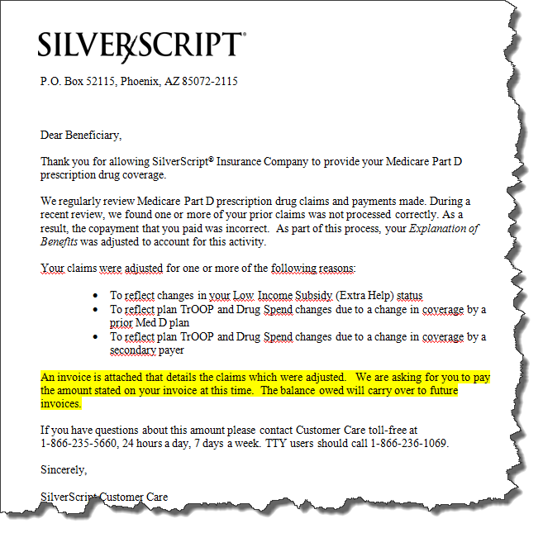

Example: SOFT Collection letter
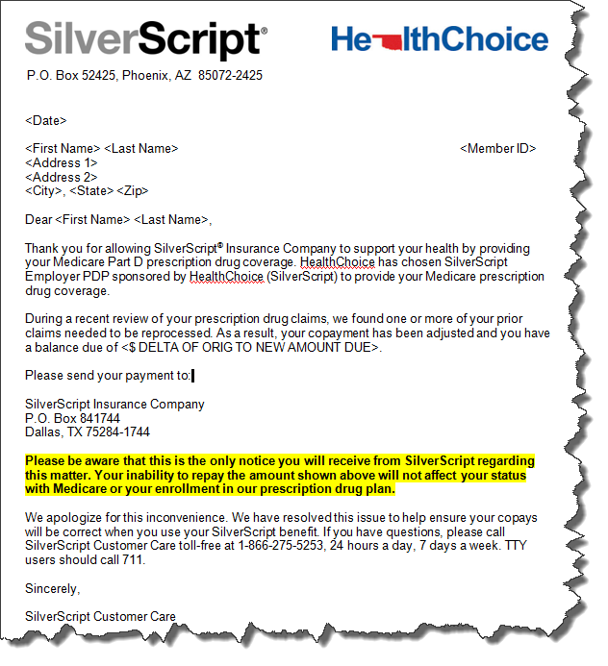

Top of the Document

Senior Team/Offline Team - Submitting Reconciliation Management Team (RMT) SalesForce Case
Refer to MED D - Senior Team - Submitting Reconciliation Management Team (RMT) SalesForce Case.

Top of the Document

Log Activity
Refer to Log Activity/Capture Activity Codes.

Top of the Document

Resolution Time
The resolution time will vary based on the issue.

Top of the Document

Related Documents
MED D - Researching and Submitting Paper Claims

Parent SOP: CALL-0048: Medicare Part D Customer Care Call Center Requirements-CVS Caremark Part D Services, L.L.C.
Abbreviations/Definitions: Abbreviations / Definitions

Top of the Document
Not To Be Reproduced Or Disclosed to Others Without Prior Written Approval
ELECTRONIC DATA = OFFICIAL VERSION – PAPER COPY = INFORMATIONAL ONLY

